**Project Documentation**

Outline :

//Project and Developer details

//Sprints planned and Tasks achieved

//Algorithms and Flowcharts

//Core concepts

//Github Repository Link

//Conclusion

**Project and Developer Details :**

* Project Details :-

                     The main purpose of this project is to create a simple email validation which can perform valid and invalid operation gmail depending upon the user input. And check user gmail valid and invalid output perform

* Developer Details :-
* Shubham phulchand gupta

**Sprints Planned and Tasks achieved :**

* STS Planning
* Tasks achieved:
* Valid email address
* Invalid email address
* Depending user input and output operation
* Invalid means incorrect user gmail and valid means correct user gmail

Algorithms and Flowcharts :-

Algorithm :-

**Step: BEGIN.**

**Step: PRINT ENTER YOUR GMAIL**

**Step: ENTER YOUR VALID GMAIL**

**Step: ENTER Check email address syntax**

**Step: USER WILL ENTER @**

**Step: Check existence of SMTP server for domain**

**Step: DO THE OPERATION VALID AND INVALID**

**Step: PRINT THE RESULT.**

**Step: EXIT.**

Flowchart:-

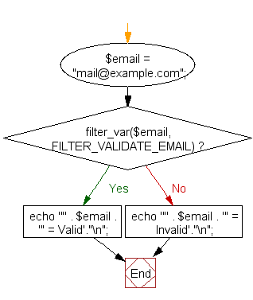

**Core Concept** :

  We have used the class, packages, while, switch, string,. Firstly we have created a package in that we have created a class. We have used valid and invalid condition is true. Once it is true it comes out of the valid gmail and displays the output.

**Github Repository link** :

https://github.com/shubz77/phase1-Assisted-project-2.git

**Conclusion:-**

 In this work we have developed a calculator for exact real number computation and performed a theoretical analysis of the algorithms and experimented on their implementation.